CS301  
Programming Assignment #3

Thomas Crow

10/28/22

## 1) ADA

## 1) Pascal

## 1) Go

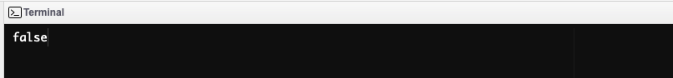

## 1) Fortran

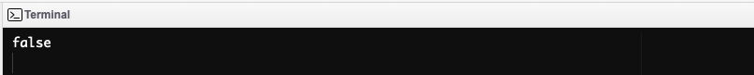

2) The languages Fortran, Pascal and Go used short circuit and did not evaluate the second conditional, which ran the function. Ada and VBScript did not and ran the second function.

3) While in our program, the second conditional was trivial in program execution, this is not always the case. If the second conditional had a significantly costly execution cost, skipping the second conditional could save considerable execution time.